Press Release
15th MARCH 2023
Kerry Healy to lead Accor’s Commercial Organisation for Middle East, Africa, Turkey & Asia Pacific

APPOINTED AS Chief Commercial Officer for group’s Premium, Midscale & Economy brands

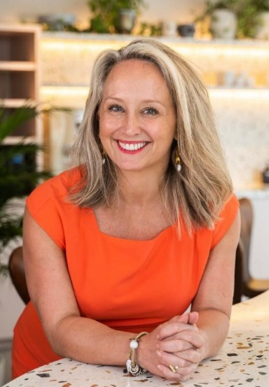
SINGAPORE – Accor, the region’s largest international hotel operator, has introduced its new Commercial organisation and executive committee, with Kerry Healy taking the lead as Chief Commercial Officer for Premium, Midscale & Economy brands in Middle East, Africa, Turkey & Asia Pacific.

An outstanding leader and skilled negotiator, Kerry has a proven track record of managing teams, building trust and designing robust strategies. Part of the Accor family since 2011, she previously served as Chief Commercial Officer for South East Asia, Japan & South Korea – a position she held with distinction since 2020.

In her expanded role, Kerry will oversee the commercial functions for a diverse region which comprises nearly 1,000 hotels – 29% of the Group’s global network – across 42 countries, under iconic brands such as Pullman, Mövenpick, Swissôtel, Novotel, Mercure and ibis. Based in Singapore, she will be able to leverage a wealth of business acumen and over 25 years of experience to meet the Group’s strategic commercial objectives.

“I am delighted to welcome Kerry to her new role. With her extensive knowledge and proven expertise, including senior management positions in the UK, Middle East, Asia and Pacific Rim, Kerry is the perfect fit to head up our commercial team at this crucial time. As global travel rebounds and our business grows from strength to strength, we need highly skilled leaders at the helm. I have the utmost confidence that Kerry’s qualities will allow us to capitalise on the exciting opportunities that lie ahead,” said Duncan O'Rourke, CEO, Middle East, Africa, Turkey & Asia Pacific.

Kerry will head up a new Commercial Executive Committee, which has been carefully curated for its members’ abilities to provide strong and effective leadership across the hub’s three key regional centres: Singapore, Sydney and Dubai.

Victoria Sertic, SVP, Brand, Marketing & Loyalty
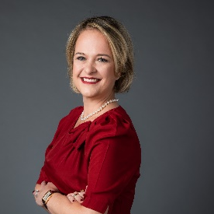
Victoria’s impressive tourism and hospitality career spans over 26 years in the tourism sector, with extensive expertise in commercial management, brand strategy and management, marketing, sales, public relations and communications. She has held various senior leadership positions in luxury hospitality and regional destination management companies driving and maximising opportunities across diverse initiatives. Most recently VP of Brand Management, Marketing & Communications for Southeast Asia, Japan & South Korea, Victoria will continue to be based in the Singapore office.

Kent Warren, SVP, Topline Performance & Business Intelligence
Based in Sydney, Kent is a highly respected hotelier with more than 28 years of high-level experience. He commenced his career in Accor in 2014 and has held numerous roles, including General Manager for several hotels, as well as the position of Regional Revenue Manager for the NSW/ACT region in Australia. Kent’s most recent role was VP Revenue and Business Intelligence for the Pacific region, and he will remain based in the Sydney office.

Antony Meguerdijian, SVP, Sales

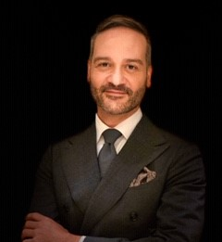
Antony brings more than 23 years of hospitality experience to his new position, with previous roles in North America, Europe, Africa, Middle East and Asia, within a variety of international hospitality organisations. He joined Accor in 2020, since when he has held the role of VP of Sales South East Asia, Japan & Korea. Antony will remain based in the Singapore office.

Amro Khoudeir, SVP, Digital & Distribution
Amro is a commercial leader with more than 15 years of digital, product, technology and management experience. He has successfully delivered digital marketing strategies, product development, integration and transformation projects for international hospitality organisations. In his most recent role, Amro managed all commercial related projects for the India, Middle East & Africa region. He will remain based in Dubai.

Sarah Fernandez, VP, PR & Communications
Sarah is a seasoned PR & Comms professional with more than 15 years of experience. She joined Accor in 2019 as Director of PR & Communications for India, Middle East & Africa. Prior to this, she was head of Marketing & Communications for Mövenpick in Asia. Alongside her position on the Executive Committee, she will also be supporting Duncan O’Rourke on his communications requirements. Sarah will remain based in the Dubai office.

“I am extremely proud to undertake this new role. I have no doubt that being part of such a vast geographical hub with key destinations, brand representation and a significant footprint will be an incredible journey, which I am excited to embark on with our new Commercial Executive Committee,” said Kerry.

As Chief Commercial Officer for Premium, Midscale & Economy brands in Middle East, Africa, Turkey & Asia Pacific, Kerry will now have responsibility for 42 countries across this vast geographical region, which spans from the shores of the Atlantic Ocean on west coast of Africa all the way to the paradise islands of the South Pacific.

Accor currently operates 993 hotels (199,095 keys) across the Middle East, Africa, Turkey and Asia Pacific region, with a pipeline of 299 hotels (64,000 keys).

For more information about Accor, please visit group.accor.com.

###

ABOUT ACCOR

Accor is a world leading hospitality group offering experiences across more than 110 countries in 5 400 properties, 10 000 food & beverage venues, wellness facilities or flexible workspaces. The Group has one of the industry’s most diverse hospitality ecosystems, encompassing more than 40 hotel brands from luxury to economy, as well as Lifestyle with Ennismore. Accor is committed to taking positive action in terms of business ethics & integrity, responsible tourism, sustainable development, community outreach, and diversity & inclusion. Founded in 1967, Accor SA is headquartered in France and publicly listed on Euronext Paris (ISIN code: FR0000120404) and on the OTC Market (Ticker: ACCYY) in the United States. For more information, please visit www.group.accor.com or follow us on Twitter, Facebook, LinkedIn, Instagram and TikTok.

Contacts media relations
Harry Greig
Director, Communications
Accor, Upper Southeast Asia
harry.greig@accor.com

Nontawan Laohakiat (Toey)
Assistant Manager, Communications
Accor, Southeast Asia, Japan & South Korea nontawan.laohakiat@accor.com

Jerome Richard
VP, Communications
Delivering Asia Communications
jr@deliveringasia.com

